**apple_c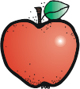Third Grade Supply List**

**2018-2019**

The following is a list of school supplies your child will need for my classroom this school year:

* 1 backpack
* 1 zipper pencil bag (no boxes)
* #2 sharpened pencils (minimum of 10) NO MECHANICAL pencils allowed \*
* 1 packs of wide-lined notebook paper
* 6 black and white composition notebooks (NO SPIRAL)
* 2 packs of dry eraser markers \*
* 1 white dry erase board 9 X 12\*
* 2 highlighters (replenish as needed)\*
* 1 box of crayons (replenish as needed)
* 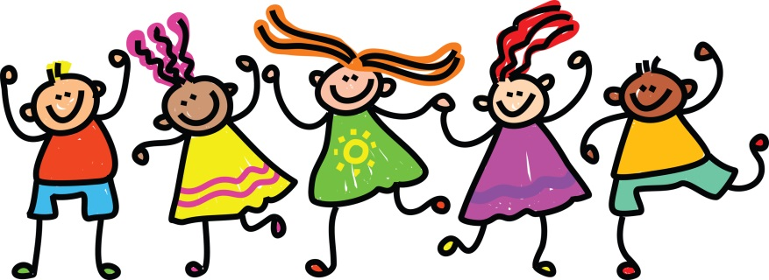4 glue sticks (replenish as needed)\*
* 1 Elmer’s glue 7 oz. (orange top)\*
* 1 ruler (inches & centimeters)
* 1 pair of Fiskar scissors
* 2 green or red ball point pens\*
* 1 large pink eraser
* 1 sharpener WITH TOP
* 1 Home learning: Yellow PLASTIC duo-tang folders with prongs and pockets
* 1 green plastic: duo-tang folders with prongs and pockets
* 1 Music: Red PLASTIC duo-tang folders with prongs and pockets
* 1 box of Kleenex \*
* 1 ream of copy paper \*
* 1 box of disinfecting wipes \*
* Liquid hand soap-NO HAND SANITIZER\*
* Optional-earphones/headphones
* Scotch tape\*
* Items identified with an \* will be collected and stored in the class.
* Summer reading assignment-select only one book

1-Separate is Never Equal-non fiction- activity- Using a piece of paper, create a collage with words and pictures around the central idea or theme in the book.

OR

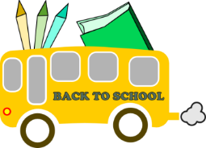Z:\Clip art\Cliparts\DJ Inkers\School Stuff\RULER_C.WMFZ:\Clip art\Cliparts\DJ Inkers\School Stuff\RULER_C.WMF2-Each Kindness-fiction-activity-Select a character-using a poster,draw a character from the book and explain his/her character traits, motivations, feelings, and actions. Use and cite text evidence